How to set-up an ANOVA

1) Under the Data tab, verify that Data Analysis link exists. If so, the ANOVA is set-up! Your done.

2) If not, go to the File Tab
3) Go to the Options Tab 4) Click on Add-Ins tab
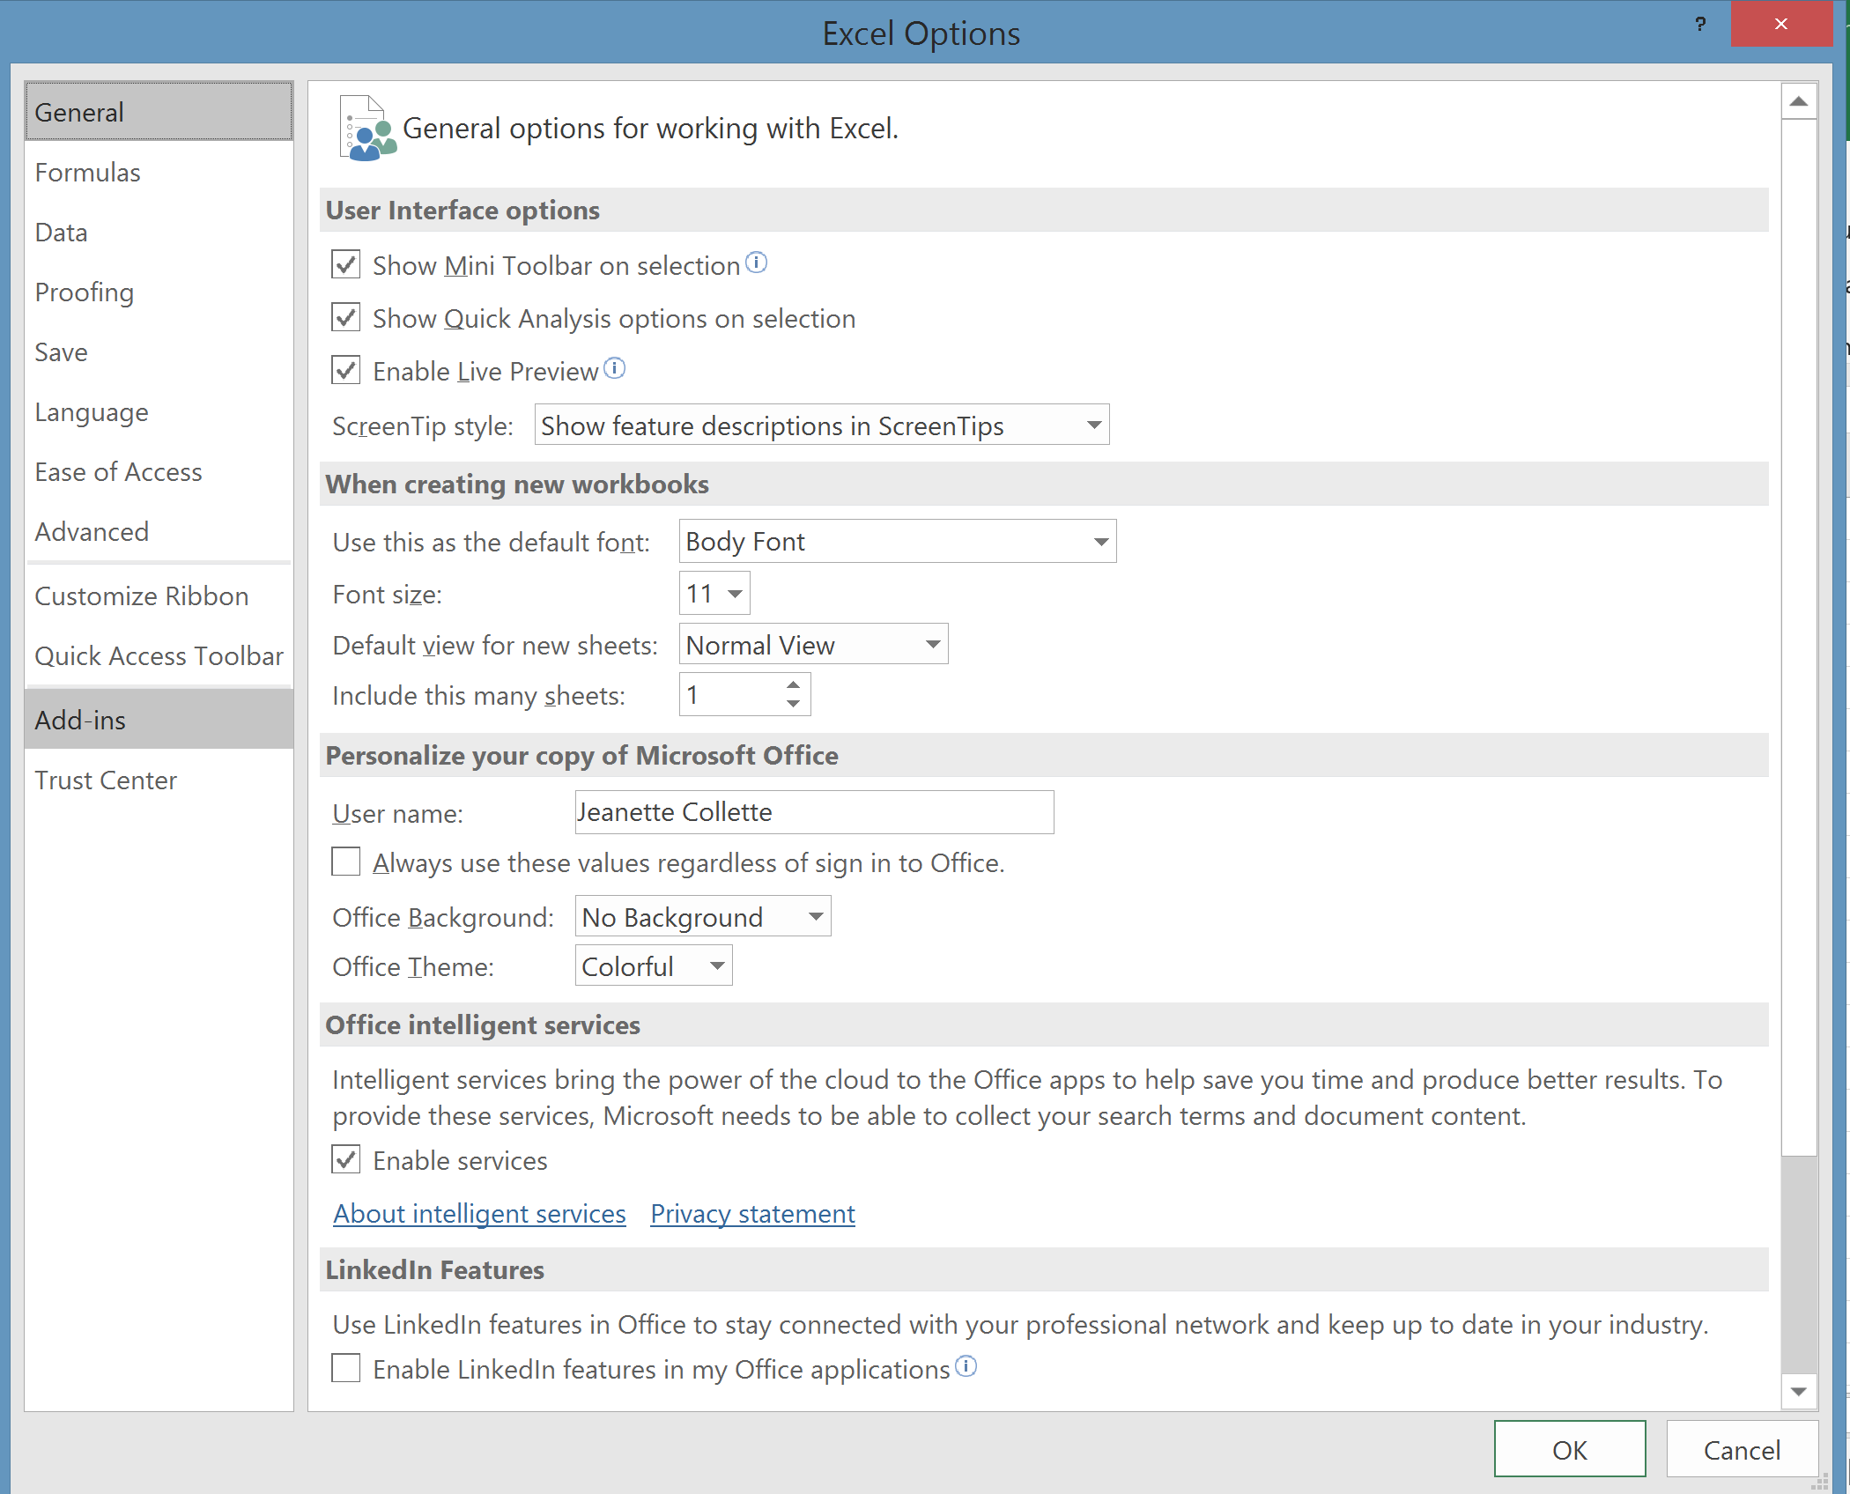

5) Click on Analysis Tool Pak and hit GO, Do not hit OK
[Note: This will be under Inactive Applications, mine was already activated)-
You do not need Analysis Toolpak VBA

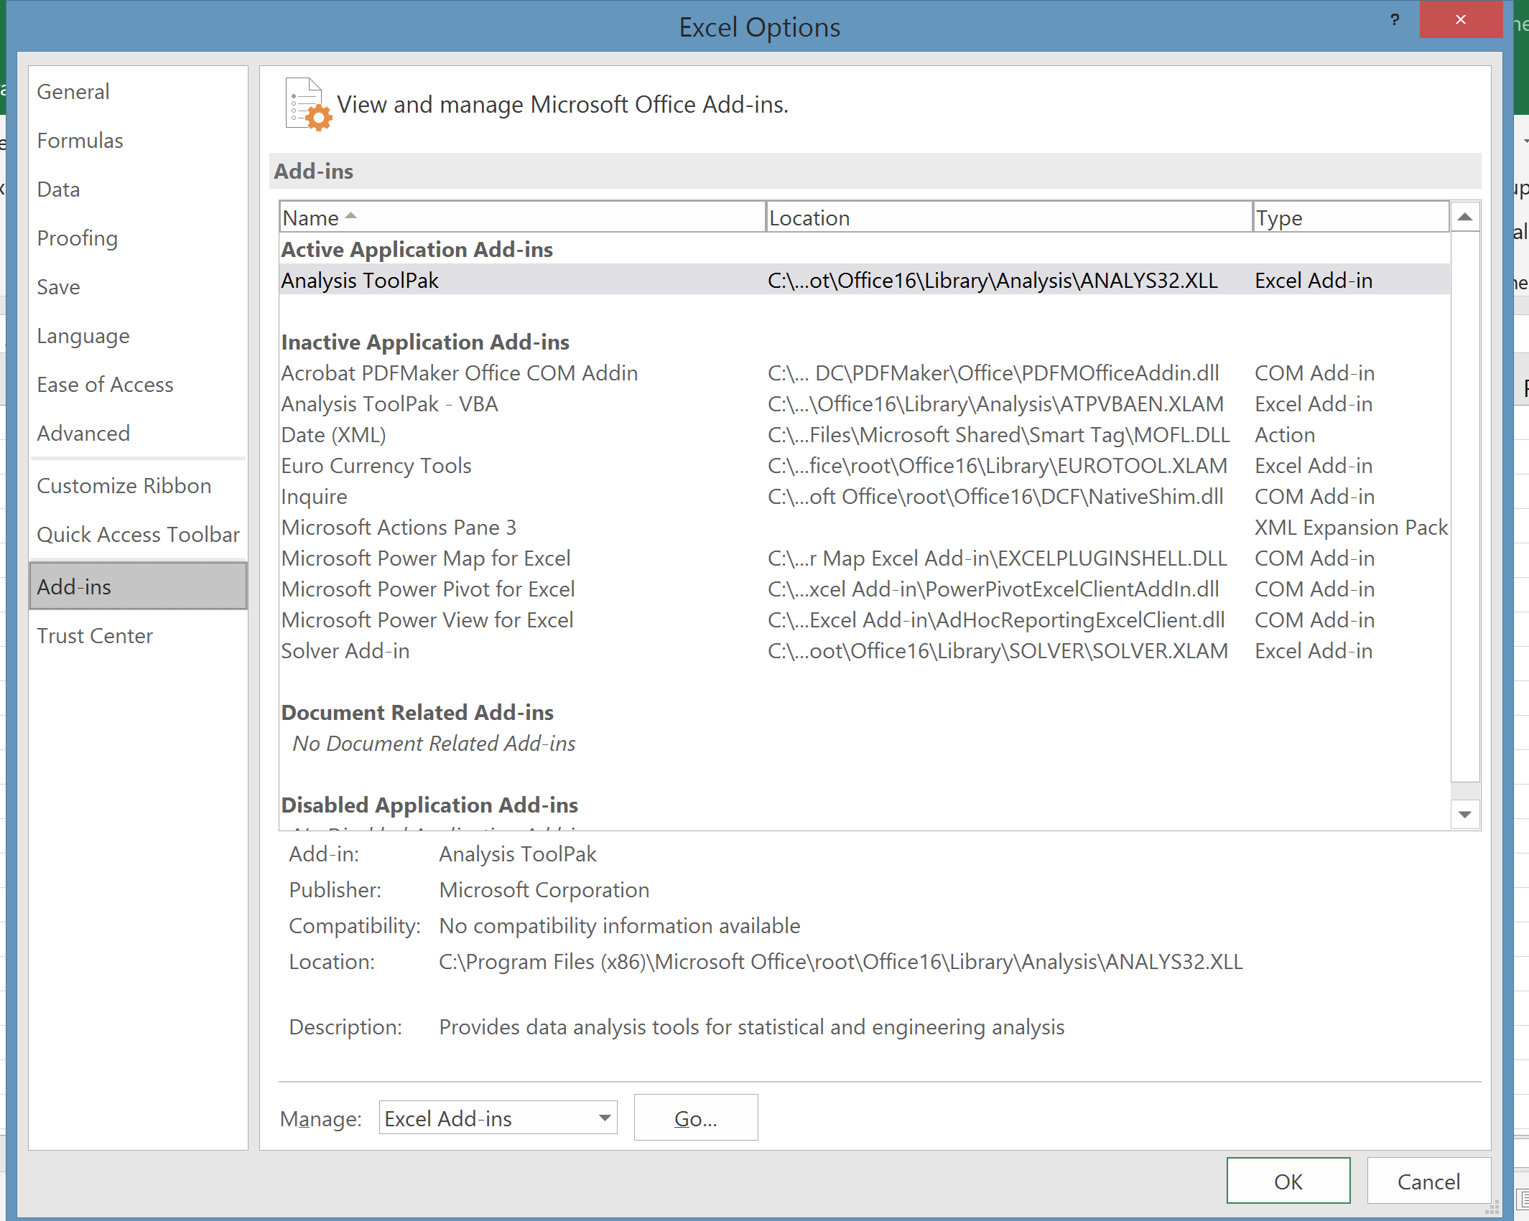

6) Check off Analysis ToolPak and click OK
7) Now you should find the Data Analysis link under the Data Tab. Click on it and chose your Test when the box pops up, then click OK

